Research Report 4 - SP-GQE empirical evaluation
Robert Oprescu

This report is the complete empirical update: 680 stratified HotpotQA distractor instances across 28 seeds. It reports per-pipeline aggregates, merged-grid selection of (n*, τ*) from 24 heatmap runs (weight 580), SP-GQE at the selected cell, paired ΔF1 versus V-RAG, graph-query validity at the protocol default, and qualitative SPARQL samples. Limitations where logging does not match the selected (n, τ) are stated explicitly.

1. Introduction
Building on Research Report 3, this document adds multi-seed heatmap aggregation, global (n, τ) selection by argmax on pooled mean F1, retrieval heatmaps, graph-query validity (precision/recall of entity sets vs gold supporting NER), and annotated SPARQL query samples from daily run logs.

2. Evaluation scale
Aggregated from 28 per-seed JSON files (680 unique question instances). Heatmap merge: 24 files, total weight 580.
Seeds (sample): 2026-05-07:seed42(n=25), 2026-05-08:seed43(n=25), 2026-05-08:seed44(n=25), 2026-05-08:seed45(n=25), 2026-05-11:seed46(n=25), 2026-05-11:seed47(n=25), 2026-05-11:seed48(n=15), 2026-05-12:seed49(n=25), … (+20 more)

3. Per-pipeline results
Pipeline | Mean F1 | 95% CI F1 | Mean EM | Sup. recall@k | P@k | n seeds
V-RAG | 0.5626 | [0.5313, 0.5940] | 0.4521 | 0.7842 | 0.6718 | 28
GQE-RAG(n=2) | 0.5622 | [0.5273, 0.5970] | 0.4576 | 0.7913 | 0.6630 | 28
SP-GQE(n=2,τ=0.5) | 0.5557 | [0.5276, 0.5839] | 0.4507 | 0.7634 | 0.6344 | 28
SP-GQE-i(n=3,τ=0.5) | 0.5443 | [0.5149, 0.5737] | 0.4469 | 0.7781 | 0.6615 | 28
GR-RAG | 0.5684 | [0.5363, 0.6004] | 0.4626 | 0.7842 | 0.6718 | 28
GF-RAG | 0.5465 | [0.5176, 0.5754] | 0.4352 | 0.7321 | 0.6308 | 28
SP-GQE(n=1,τ=0.6) | 0.5778 | [0.5501, 0.6055] | — | — | 0.6469 | 24

SP-GQE(n=1,τ=0.6) (last row): post-hoc argmax on pooled heatmap mean F1 (see Section 4); not a pre-registered protocol arm. EM and supporting-title recall were not swept in the (n, τ) grid. n=24 heatmap seeds (protocol arms: n=28 seeds).

4. Heatmap aggregation and selected (n, τ)
Selection criterion: argmax on merged sample-size-weighted mean_f1_grid. Global best on merged grid: n=1, τ=0.6 (pooled mean F1 = 0.5766, P@k = 0.6486). Per-seed metrics use this same cell (not per-seed argmax).
SP-GQE (n=1, τ=0.6) - mean F1 0.5778 [0.5501, 0.6055]; mean P@k 0.6469 [0.6309, 0.6629]; n=24 heatmap seeds.
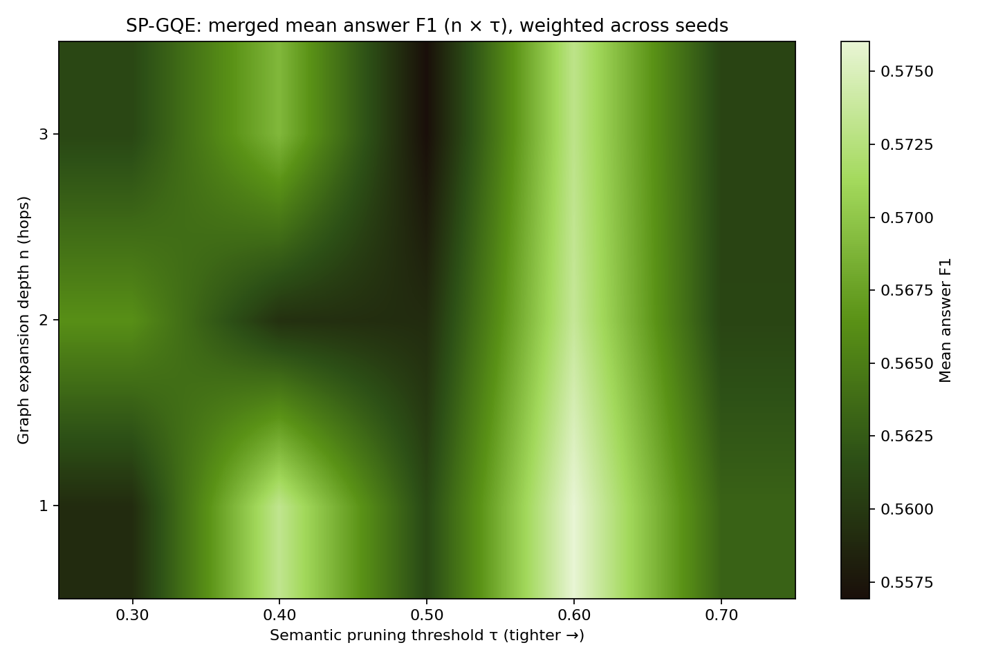
Merged mean answer F1 over (n, τ); star marks pooled argmax.

Figure: heatmap_merged_mean_p_at_k.png
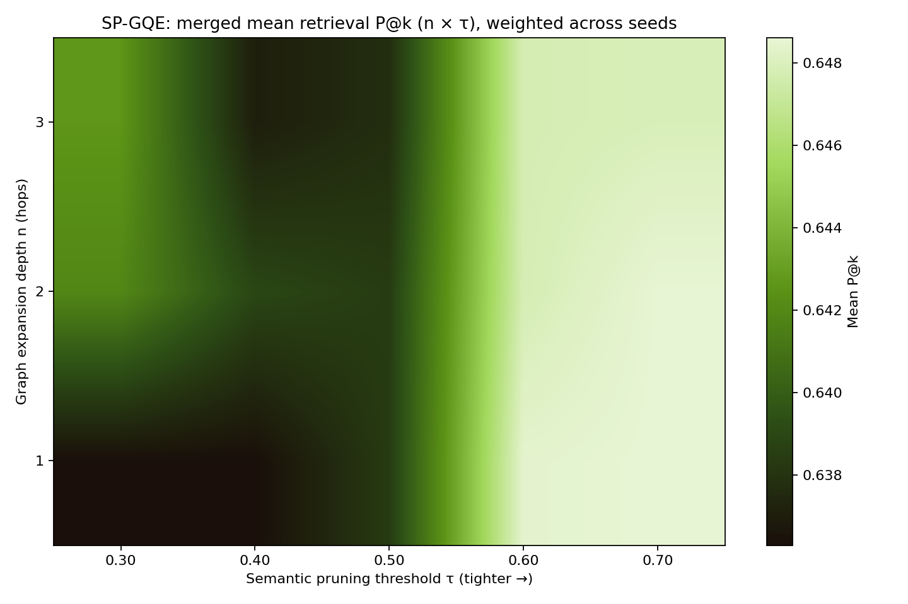
Merged mean retrieval P@k over (n, τ).

5. Paired ΔF1 (SP-GQE − V-RAG)
Table - seed-level ΔF1 at merged-selected (n*, τ*):
Scope | Mean Δ | 95% CI | n
all seeds (SP-GQE n=1, τ=0.6) | 0.0079 | [-0.0133, 0.0292] | 24

Question-level pairs (heatmap seeds only; SP-GQE arm in log: n=2, tau=0.5 (protocol default in daily_runs)). Bridge/comparison rows do not use the heatmap cell F1 unless re-logged per question.
Subset | Mean Δ | Bootstrap 95% CI | n pairs
bridge | -0.0114 | [-0.0375, 0.0142] | 279
comparison | -0.0085 | [-0.0398, 0.0222] | 301

Appendix - protocol default SP-GQE (n=2, τ=0.5):
Subset | Mean Δ | Bootstrap 95% CI | n pairs
bridge | -0.0034 | [-0.0279, 0.0211] | 327
comparison | -0.0086 | [-0.0375, 0.0202] | 353

6. Graph-query validity
Graph-query validity below is recomputed from “graph_query_log” at τ=0.6 (cosine prune on stored similarities). Branch 1 n-hop structure in the log was captured at n=2 during the run; merged selection n=1 may differ - see validity section.
Stage | Mean precision | Mean recall | n questions
Branch 1 (n-hop) | 0.3411 | 0.5859 | 680
Branch 2 (keyword) | 0.3737 | 0.1668 | 680
Union | 0.3092 | 0.6256 | 680
Kept after τ=0.5 | 0.4465 | 0.2146 | 680

7. SPARQL query samples
Excerpted from 2026-05-07__seed42__n25__queries.md (seed 42, SP-GQE n=2, τ=0.5). For each question we show both branch queries, entity sets returned by each SPARQL execution, fusion/pruning outcomes, top cosine scores, and per-stage precision/recall against gold supporting entities.

[comparison] Which of the following bands is considered "one of the most accomplished and creative Christian bands of the '90s": Poor
qid: 5abeb91c5542994516f45400 | gold answer: Poor Old Lu | answer F1 — SP-GQE: 1.000, V-RAG: 1.000 | seed entities: ['christian', 'one', "the '90s"]
Branch - structural n-hop (SPARQL)
PREFIX spg: <http://spgqe.local/>
SELECT DISTINCT ?t WHERE {
VALUES ?s { <http://spgqe.local/e#the_90s> <http://spgqe.local/e#christian> <http://spgqe.local/e#one> }
{ ?s spg:coOccurs ?t } UNION
{ ?s spg:coOccurs/spg:coOccurs ?t }
}
Query results (n=32): ['1854', '1990s', '2005', '6009', '9', '90s', 's", ', ', ', ', ', ', ', … (+14 more)]
Branch — keyword / semantic (SPARQL)
PREFIX spg: <http://spgqe.local/>
PREFIX rdfs: <http://www.w3.org/2000/01/rdf-schema#>
SELECT DISTINCT ?e ?label WHERE {
?e a spg:Entity ; rdfs:label ?label .
FILTER(CONTAINS(LCASE(STR(?label)), "following") || CONTAINS(LCASE(STR(?label)), "bands") || CONTAINS(LCASE(STR(?label)), "accomplished") || CONTAINS(LCASE(STR(?label)), "creative") || CONTAINS(LCASE(STR(?label)), "christian") || CONTAINS(LCASE(STR(?label)), "poor") || CONTAINS(LCASE(STR(?label)), "old") || CONTAINS(LCASE(STR(?label)), "shudder"))
}
Query results (n=7): ['a poor old man', 'christian', 'contemporary christian music', 'poor old man', 'shudder to think', 'the poor old', 'the poor old lady']
Fusion and pruning
Union |A ∪ B| = 35 entities.
Kept after τ = 0.5 (n = 9): ['christian', 'contemporary christian music', 'lu', 'one', 'poor old man', 'shudder to think', '90s", ', ', ']
Top candidate cosine similarities (entity → score):
• shudder to think - 0.841
• lu - 0.715
• contemporary christian music - 0.694
• the poor old - 0.573
• poor old man - 0.547
• the poor old lady - 0.514
• a poor old man - 0.497
• two - 0.430
Graph-query validity (vs gold supporting NER):
Stage | Precision | Recall
Branch 1 (n-hop) | 0.219 | 0.467
Branch 2 (keyword) | 0.286 | 0.133
Union | 0.200 | 0.467
Kept after τ | 0.556 | 0.333

Gold supporting entities (reference): ['1986', 'aaron sprinkle', 'american', 'christian', 'contemporary christian music', 'dischord records', 'hunter', 'jesse sprinkle', 'lu', 'nick barber', 'one', 'scott hunter', "the '90s", 'three', 'washington']

[comparison] Which band, A Silent Film or The Frames, has more members?
qid: 5adfda9655429925eb1afac0 | gold answer: The Frames | answer F1 — SP-GQE: 1.000, V-RAG: 1.000 | seed entities: ['frames']
Branch — structural n-hop (SPARQL)
PREFIX spg: <http://spgqe.local/>
SELECT DISTINCT ?t WHERE {
VALUES ?s { <http://spgqe.local/e#frames> }
{ ?s spg:coOccurs ?t } UNION
{ ?s spg:coOccurs/spg:coOccurs ?t }
}
Query results (n=6): ['1990', 'dublin', 'frames', 'glen hansard', 'irish', 'six']
Branch — keyword / semantic (SPARQL)
PREFIX spg: <http://spgqe.local/>
PREFIX rdfs: <http://www.w3.org/2000/01/rdf-schema#>
SELECT DISTINCT ?e ?label WHERE {
?e a spg:Entity ; rdfs:label ?label .
FILTER(CONTAINS(LCASE(STR(?label)), "band") || CONTAINS(LCASE(STR(?label)), "silent") || CONTAINS(LCASE(STR(?label)), "film") || CONTAINS(LCASE(STR(?label)), "frames") || CONTAINS(LCASE(STR(?label)), "members"))
}
Query results (n=6): ['a_frames', 'frames', 'pordenone silent film festival', 'silent songs', 'the niles silent film museum', 'the pordenone silent film festival']
Fusion and pruning
Union |A ∪ B| = 11 entities.
Kept after τ = 0.5 (n = 6): ['a_frames', 'frames', 'pordenone silent film festival', 'silent songs', 'the niles silent film museum', 'the pordenone silent film festival']
Top candidate cosine similarities (entity → score):
• a_frames - 0.769
• the pordenone silent film festival - 0.686
• silent songs - 0.662
• pordenone silent film festival - 0.651
• the niles silent film museum - 0.610
• six - 0.356
• 1990 - 0.332
• irish - 0.284
Graph-query validity (vs gold supporting NER):
Stage | Precision | Recall
Branch 1 (n-hop) | 1.000 | 0.286
Branch 2 (keyword) | 0.167 | 0.048
Union | 0.545 | 0.286
Kept after τ | 0.167 | 0.048

Gold supporting entities (reference): ['1990', '6 october 2008', 'coldplay, snow patrol and the killers', 'colm mac', 'dublin', 'english', 'first', 'frames', … (+13 more)]

[bridge] What type of profession does Alexandra David-Néel and Jack Kerouac have in common?
qid: 5a886098554299206df2b248 | gold answer: writer | answer F1 — SP-GQE: 1.000, V-RAG: 1.000 | seed entities: ['alexandra david-néel', 'jack kerouac']
Branch — structural n-hop (SPARQL)
PREFIX spg: <http://spgqe.local/>
SELECT DISTINCT ?t WHERE {
VALUES ?s { <http://spgqe.local/e#alexandra_david_n_el> <http://spgqe.local/e#jack_kerouac> }
{ ?s spg:coOccurs ?t } UNION
{ ?s spg:coOccurs/spg:coOccurs ?t }
}
Query results (n=58): ['"finnegans wake', '1929', '1950', '1953', '1956 to 1959', '1957', '1962', '1963', '24 october 1868', '30', … (+15 more)]
Branch — keyword / semantic (SPARQL)
PREFIX spg: <http://spgqe.local/>
PREFIX rdfs: <http://www.w3.org/2000/01/rdf-schema#>
SELECT DISTINCT ?e ?label WHERE {
?e a spg:Entity ; rdfs:label ?label .
FILTER(CONTAINS(LCASE(STR(?label)), "type") || CONTAINS(LCASE(STR(?label)), "profession") || CONTAINS(LCASE(STR(?label)), "alexandra") || CONTAINS(LCASE(STR(?label)), "david") || CONTAINS(LCASE(STR(?label)), "jack") || CONTAINS(LCASE(STR(?label)), "kerouac"))
}
Query results (n=10): ['alexandra david-néel', 'david-néel', 'jack', 'jack duluoz', 'jack kerouac', 's", ', ', ', ', ', ', ']
Fusion and pruning
Union |A ∪ B| = 61 entities.
Kept after τ = 0.5 (n = 11): ['alexandra david-néel', 'david-néel', 'jack', 'jack duluoz', 'jack kerouac', 's", ', ', ', ', ', ', ', ', ']
Top candidate cosine similarities (entity → score):
• jack kerouac's - 0.910
• the jack kerouac school - 0.792
• kerouac - 0.745
• david-néel - 0.724
• jack - 0.691
• jean-louis kérouac - 0.621
• the jack kerouac school of disembodied poetics - 0.585
• jack duluoz - 0.575
Graph-query validity (vs gold supporting NER):
Stage | Precision | Recall
Branch 1 (n-hop) | 0.397 | 0.920
Branch 2 (keyword) | 0.400 | 0.160
Union | 0.377 | 0.920
Kept after τ | 0.455 | 0.200

Gold supporting entities (reference): ['1924', '1929', '24 october 1868', '30', 'alan watts', 'alexandra david-néel', 'allen ginsberg', 'american', … (+17 more)]

8. Conclusions
Across 28 seeds, GQE-RAG and GR-RAG remain competitive on mean F1; merged-grid SP-GQE at (n=1, τ=0.6) reaches 0.5778 mean F1 on heatmap seeds but paired improvements over V-RAG are not statistically decisive at α≈0.05 (CIs include zero). Validity diagnostics show complementary branches (union recall > branch 2) and higher precision after τ pruning at the cost of recall.

References (selection)
- Lewis, P., et al. (2020). Retrieval-augmented generation for knowledge-intensive NLP. NeurIPS.
- Yang, Z., et al. (2018). HotpotQA: diverse, explainable multi-hop QA. EMNLP.
- Edge, D., et al. (2024). From local to global: Graph RAG (technical report / blog).

